Final Report
Staff-Graded Assignment: AWS RDS – MySQL

Name: Ashfaaq Feroz Muhammad
ID: 2023EBCS005

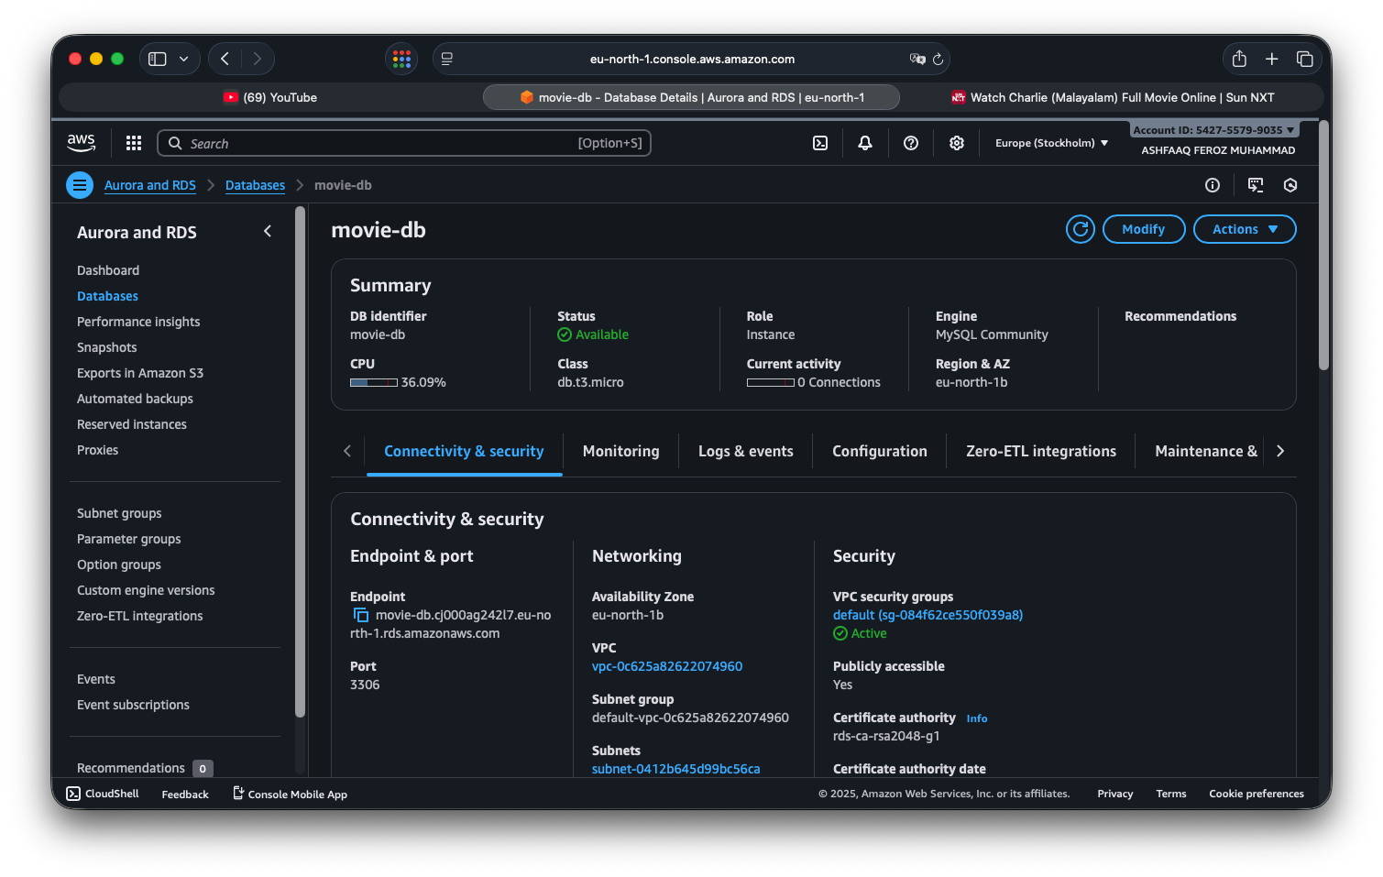
AWS My SQL Database Dashboard:

- Created AWS account and created free tier database.
- Used Endpoint to connect File to database.

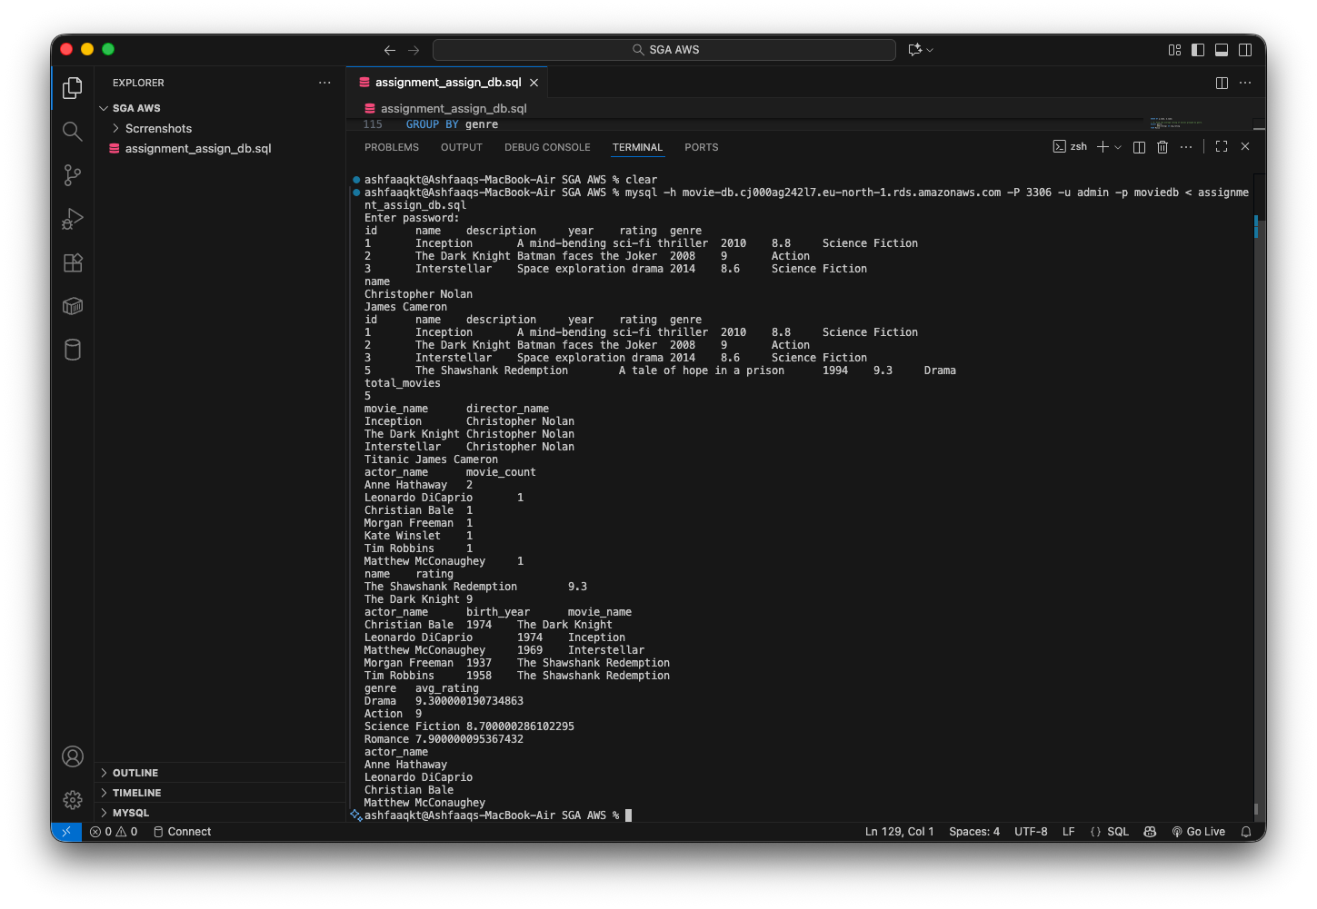
First General Test if all are connected and working well

- Entered all the Queries in SQL file and ran a general Test after connecting to the database through terminal.

Query 1:
SELECT *
FROM Movie
WHERE year > 2000;
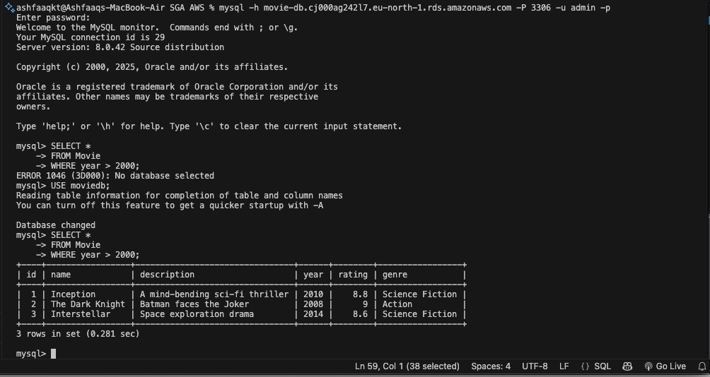

Used the database

The query 1 output.

Query 2:
SELECT name
FROM Person
WHERE role = 'Director';
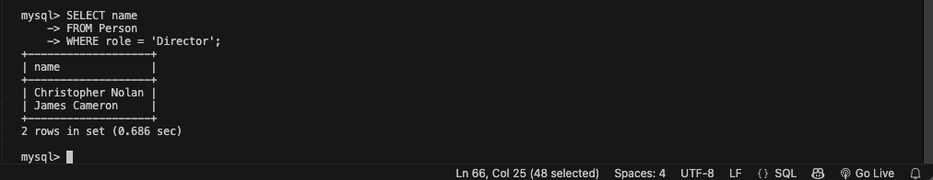

Query 3:

SELECT *
FROM Movie
WHERE rating > 8.0;
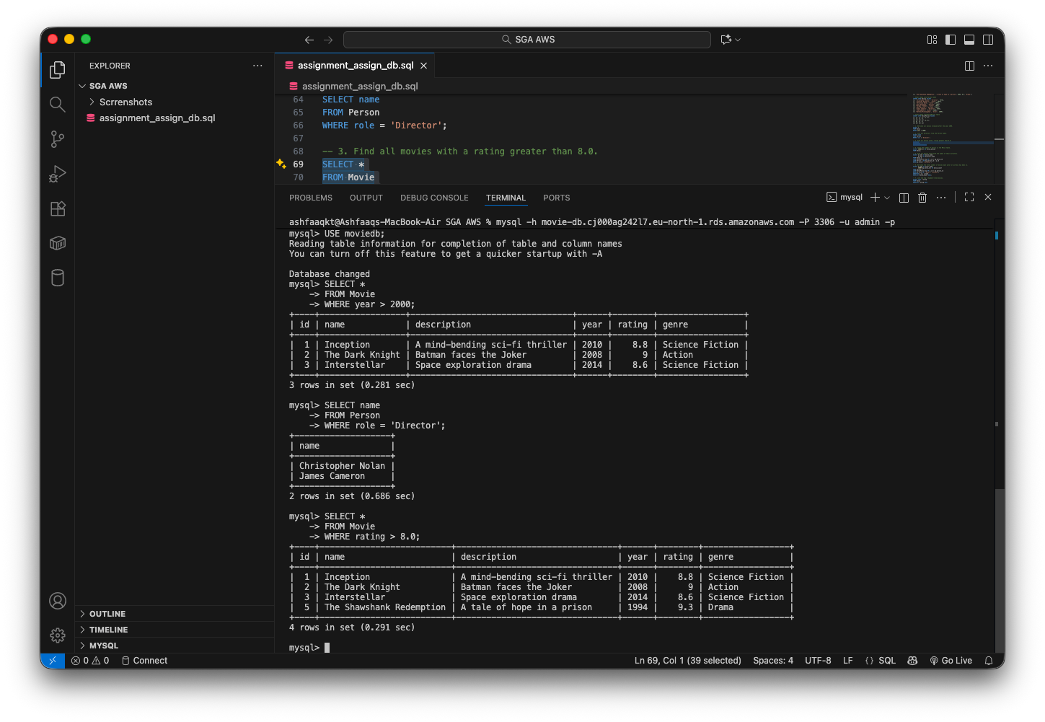

Query 4:

SELECT COUNT(*) AS total_movies
FROM Movie;

Query 5:

SELECT m.name AS movie_name,
p.name AS director_name
FROM Movie m
JOIN MoviePerson mp ON m.id = mp.movie_id
JOIN Person p ON mp.person_id = p.id
WHERE p.role = 'Director';
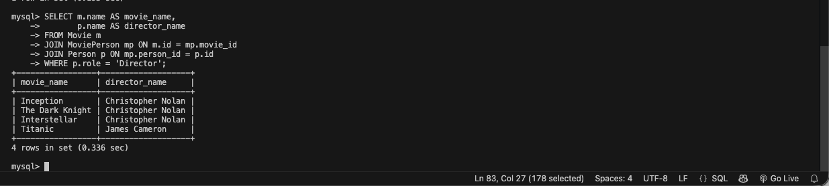

Query 6:

SELECT p.name AS actor_name,
COUNT(mp.movie_id) AS movie_count
FROM Person p
JOIN MoviePerson mp ON p.id = mp.person_id
WHERE p.role IN ('Actor', 'Actress')
GROUP BY p.id, p.name
ORDER BY movie_count DESC;
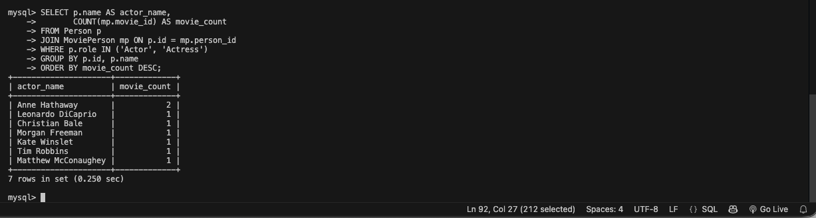

Query 7:

SELECT name, rating
FROM Movie
ORDER BY rating DESC
LIMIT 2;
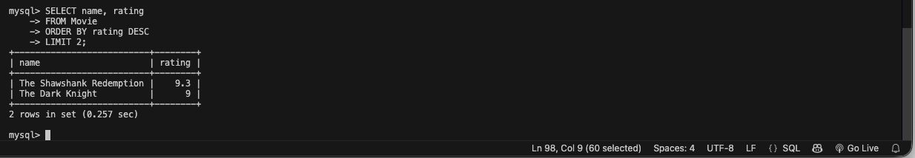

Query 8:

SELECT p.name AS actor_name,
p.birth_year,
m.name AS movie_name
FROM Person p
JOIN MoviePerson mp ON p.id = mp.person_id
JOIN Movie m ON mp.movie_id = m.id
WHERE p.role IN ('Actor', 'Actress')
AND p.birth_year < 1975
ORDER BY p.name, m.name;
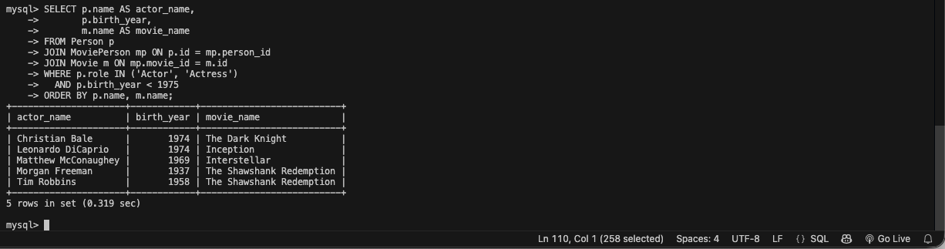

Query 9:

SELECT genre,
AVG(rating) AS avg_rating
FROM Movie
GROUP BY genre
ORDER BY avg_rating DESC;
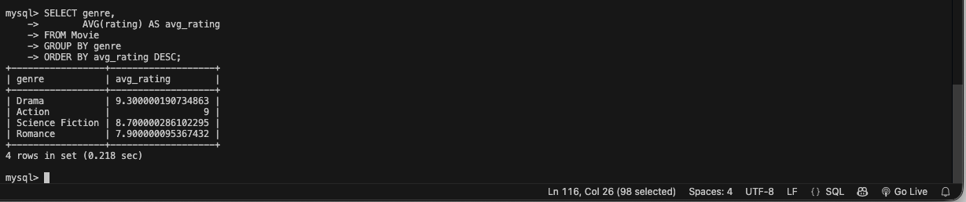

Query 10:

SELECT DISTINCT p2.name AS actor_name
FROM Person p1
JOIN MoviePerson mp1 ON p1.id = mp1.person_id
JOIN Movie m ON mp1.movie_id = m.id
JOIN MoviePerson mp2 ON m.id = mp2.movie_id
JOIN Person p2 ON mp2.person_id = p2.id
WHERE p1.role = 'Director'
AND p1.name = 'Christopher Nolan'
AND p2.role IN ('Actor', 'Actress');
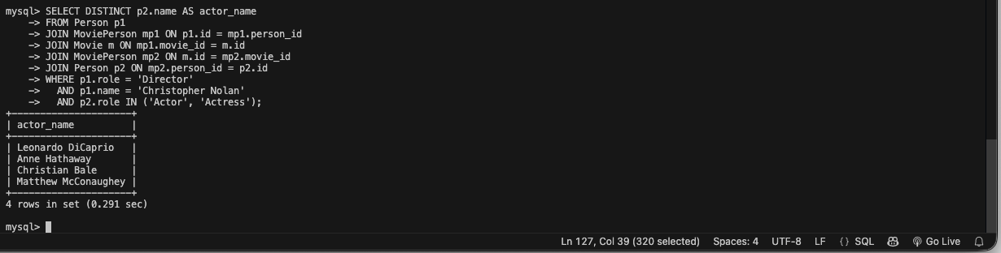

THE END

